**Content**

1. Terms 2

1. Intrinsic functions 2

2. Systems Manager Inventory 2

3. Secrets Manager vs Parameter Store 2

4. BlockDeviceMapping 2

5. OpsWorks: Stacks and Layers 2

6. Systems Manager Automation 3

7. RDS Multi-AZ vs Read Replicas 3

8. Pre-baking AMIs 4

9. CloudFromation: Deletion and Snapshots 4

10. Statefulness of the security groups 4

11. OIDC compatible IDP 4

12. Amazon Inspector 5

13. Multiple Lambdas 5

1. Terms
   1. Intrinsic functions

You can use intrinsic functions only in specific parts of a template: Properties, outputs, metadata attributes and update policy attributes.

* 1. Systems Manager Inventory

AWS Systems Manager Inventory provides visibility into your Amazon EC2 and on-premises computing environment. You can use Inventory to collect metadata from your managed instances. You can store this metadata in a central Amazon Simple Storage Service (Amazon S3) bucket, and then use built-in tools to query the data and quickly determine which instances are running the software and configurations required by your software policy, and which instances need to be updated. You can also configure and view inventory data from multiple AWS Regions and accounts.

* 1. Secrets Manager vs Parameter Store

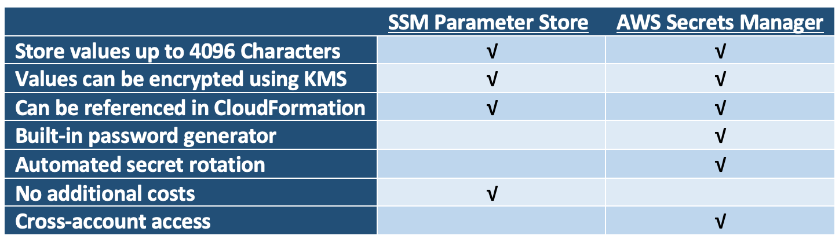

* 1. BlockDeviceMapping

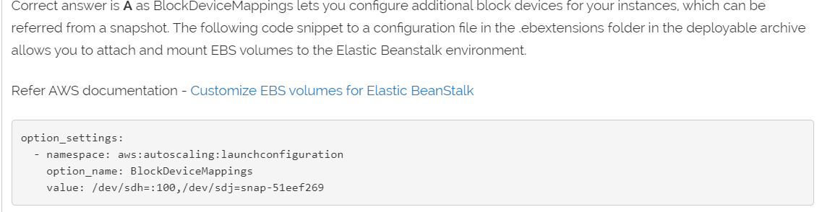

* 1. OpsWorks: Stacks and Layers

**Stack:** The stack is the top-level AWS OpsWorks Stacks entity. It represents a set of instances that you want to manage collectively, typically because they have a common purpose such as serving PHP applications.

**Layers**: Every stack contains one or more layers, each of which represents a stack component, such as a load balancer or a set of application servers.

* Each layer in a stack must have at least one instance and can optionally have multiple instances.
* Each instance in a stack must be a member of at least one layer, except for registered instances.

**Instances:** An instance represents a computing resource, such as an Amazon EC2 instance, which handles the work of serving applications, balancing traffic, and so on. An instance's operating system can have any of several Linux distributions, or Windows Server 2012 R2.

Use AWS OpsWorks Stacks to add instances to a stack. The instances that you add represent Amazon EC2 instances.

**Apps:** An AWS OpsWorks Stacks app represents code that you want to run on an application server. The code itself resides in a repository such as an Amazon S3 archive; the app contains the information required to deploy the code to the appropriate application server instances.

**Coocbooks:** AWS OpsWorks Stacks uses Chef cookbooks to handle tasks such as installing and configuring packages and deploying apps.

* 1. Systems Manager Automation
* Systems Manager Automation simplifies common maintenance and deployment tasks of EC2 instances and other AWS resources. Automation enables you to do the following:
* Build Automation workflows to configure and manage instances and AWS resources.
* Create custom workflows or use pre-defined workflows maintained by AWS.
* Receive notifications about Automation tasks and workflows by using Amazon CloudWatch Events.
* Monitor Automation progress and execution details by using the Amazon EC2 or the AWS Systems Manager console.
  1. RDS Multi-AZ vs Read Replicas

**Multi-AZ:** Multi-AZ deployments provide enhanced availability for database instances within a single AWS Region. With Multi-AZ, your data is synchronously replicated to a standby in a different AZ. If a failure occurs, your availability impact is limited to time that automatic failover takes to complete. This helps to achieve increased availability.

**Read Replica:** When you create a Read Replica, you first specify an existing DB instance as the source. Then Amazon RDS takes a snapshot of the source instance and creates a read-only instance from the snapshot. The source DB must have automatic backups enabled for setting up read replica. Read Replica can be manually promoted as a standalone database instance.

* 1. Pre-baking AMIs

Can reduce the bootstrapping time considerably.

* 1. CloudFromation: Deletion and Snapshots

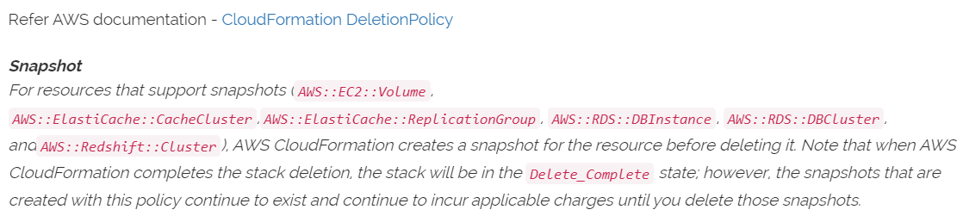

* 1. Statefulness of the security groups

„Responses to allowed traffic are also allowed, even if the rules in the SG do not permit it“

ACLs are stateless, responses are subject of ACL rules.

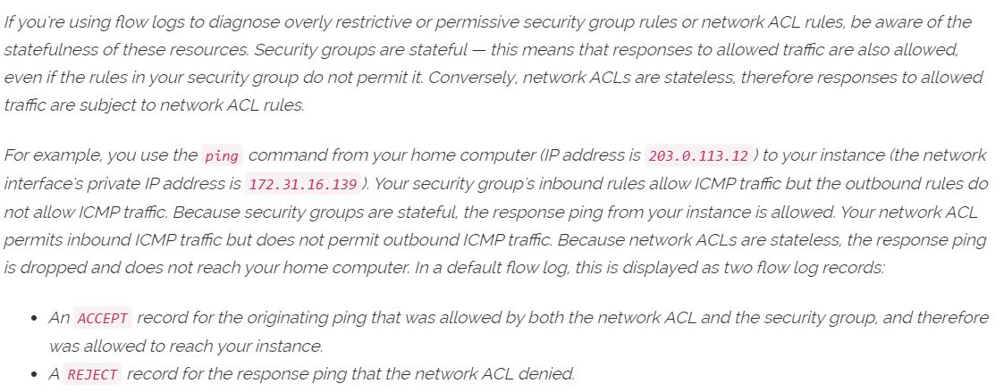

* 1. OIDC compatible IDP

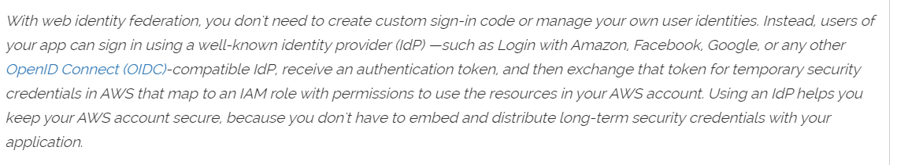

* 1. Amazon Inspector

Amazon Inspector is an automated security assessment service that helps improve the security and compliance of applications deployed on AWS. Amazon Inspector automatically assesses applications for exposure, vulnerabilities, and deviations from best practices.

* 1. Multiple Lambdas

Having multiple Lambdas reading from the DynamoDB stream might lead to request throttling. Using a single Lambda function to read and pass the payload to other functions would reduce the load and provide a cost-effective solution.

* 1. ELB Health Checks
  2. AWS Config
  3. Cloud HSM
  4. EBS Encryption
  5. AutoScaling group properties
* SlowDown
* WaitTime
* PauseTime
* CoolDown
  1. AutoScaling best practices - Scale in events, metrics